*Documentation Design*

*Project Title*

***Vinegar-food***

*Supervisor*

***Muhammad Hamza***

|  |  |  |
| --- | --- | --- |
| **Batch** | 2409C1 | |
| **Group** | **D** | |
| **Serial No.** | **Enrollment Number** | **Students Name** |
| 1. | Student1600657 | Syed Muhammad Faisal |
| 2. | Student1605847 | Muhammad Saad Anwar Malick |
| 3. | Student1600656 | Abdul Rehman |
| 4. | Student1605835 | Hisban Shahzad |
| 5. | Student1608421 | Taha |

**Group Details**

**Acknowledgement**

* You must also include a space allotment for the recipient’s signature and date. It is important that the acknowledgement receipt is signed over the printed name of the recipient and dated. This will serve as proof of receipt and confirmation of the condition of the documents and items received. You also browse our Advance Receipt.
* You must also include a space allotment for the recipient’s signature and date. It is important that the acknowledgement receipt is signed over the printed name of the recipient and dated. This will serve as proof of receipt and confirmation of the condition of the documents and items received. You also browse our Advance Receipt.

**Problem Definition**

Vinegar Food Restaurant which is the flagship brand of JADONS Ltd has spread over its aroma in this industry over the past few decades. Known as “the Serving plates” with 72 different rotating menus and 240000 delicacies throughout the country.

The organization wants a website to be made which should spread the aroma online. The main Highlights of the restaurant must be highlighted in the website. The restaurant has more than 1000 branches till date.

**Customer Requirement Specification**

The Web site is to be created based on the following requirements.

1. Home page must add header section with an image which would show different range of dishes images.
2. The menu list must be added in one section of the website
3. The bottom navigation panel must be designed.
4. Navigation of the website must be made user friendly.
5. Links such as
   * Home
   * About us
   * Meals
     1. Regular
     2. Lunch
     3. Snacks
     4. Desert
     5. Beverages
   * Gallery
   * Awards
   * Catering
   * Recipe of the month
   * Contact us
   * Feedback  (can add query, suggestion or complaints)
6. You can add additional links as well as modify but make sure all the type of food must be included.
7. Look and feel must be made user friendly.
8. Uniformity and Navigation must be made smooth throughout the website.
9. Site map, Gallery, about us, Queries link, Contact us link must be added.

**Scope**

* On a food website, include a variety of engaging content: recipes, cooking tips, ingredient guides, nutrition information, and food trends. Adding restaurant reviews, meal planning advice, or personal stories related to food can also help connect with visitors.

**Aggregated Site Map**

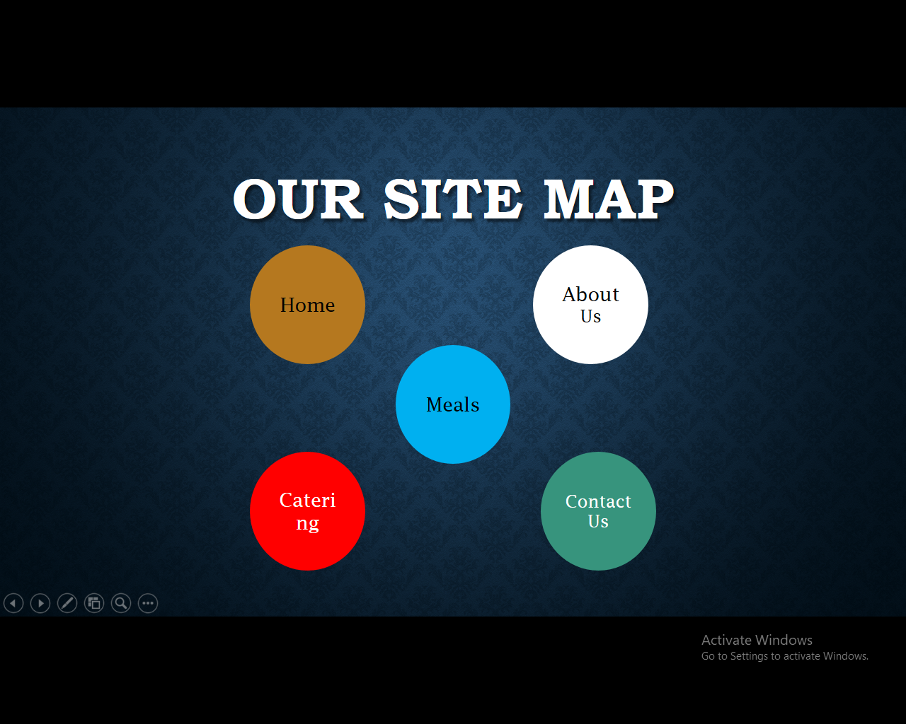

HOME: (index.html)

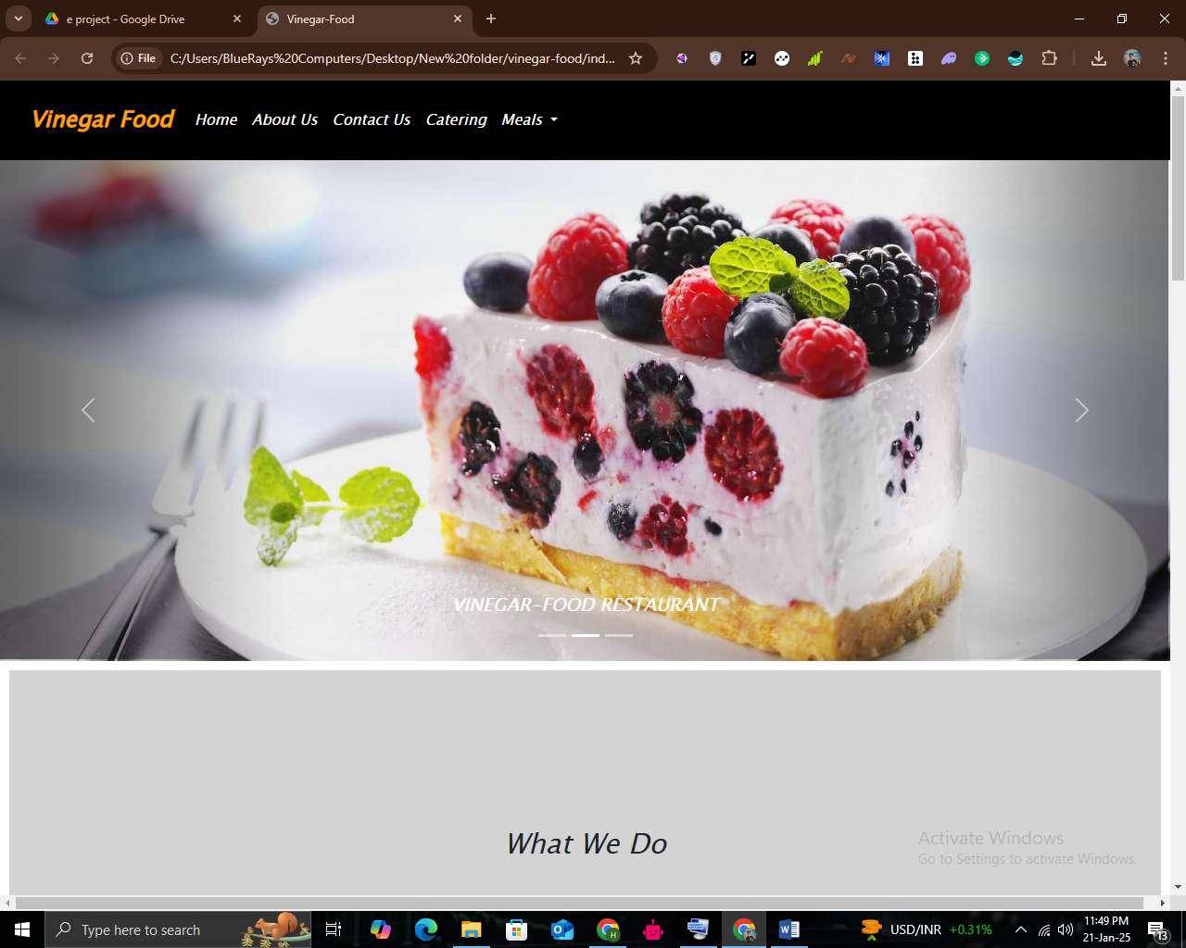

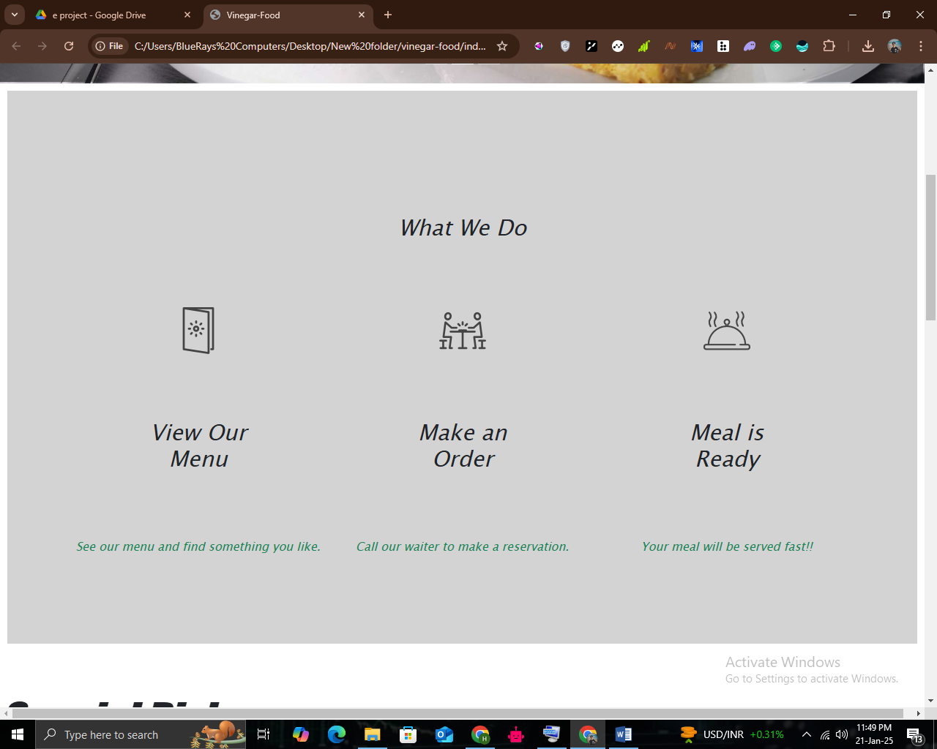

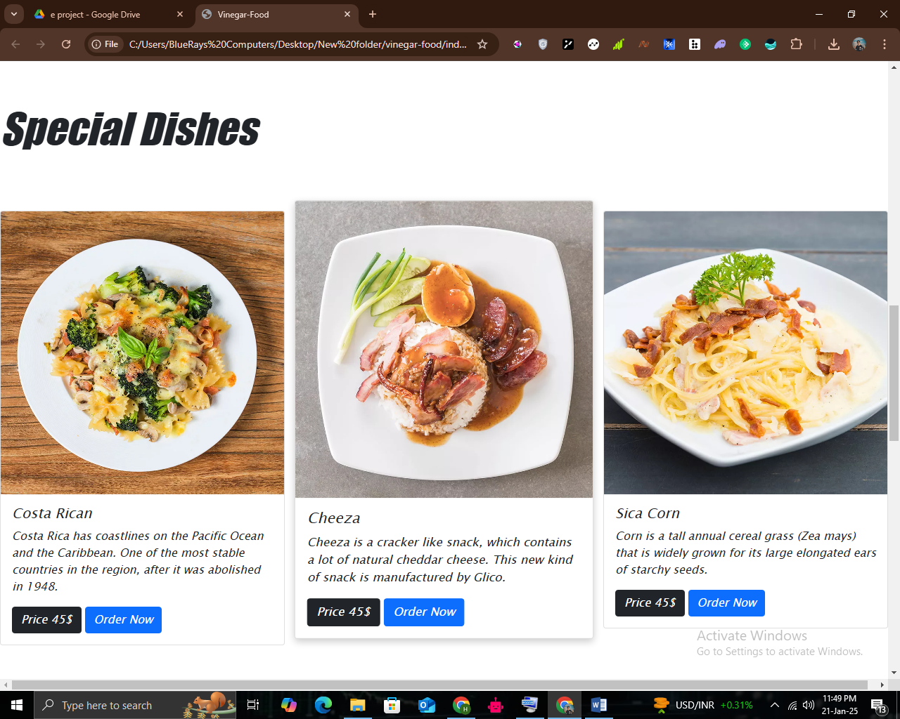

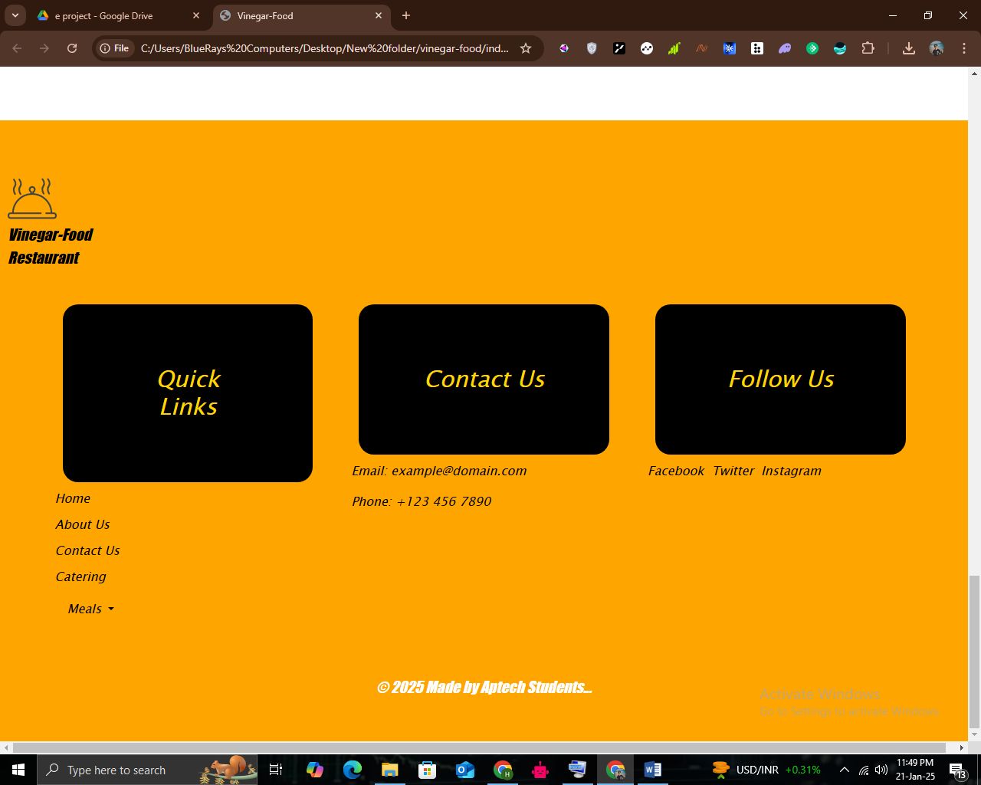

ABOUT US: (about.html)

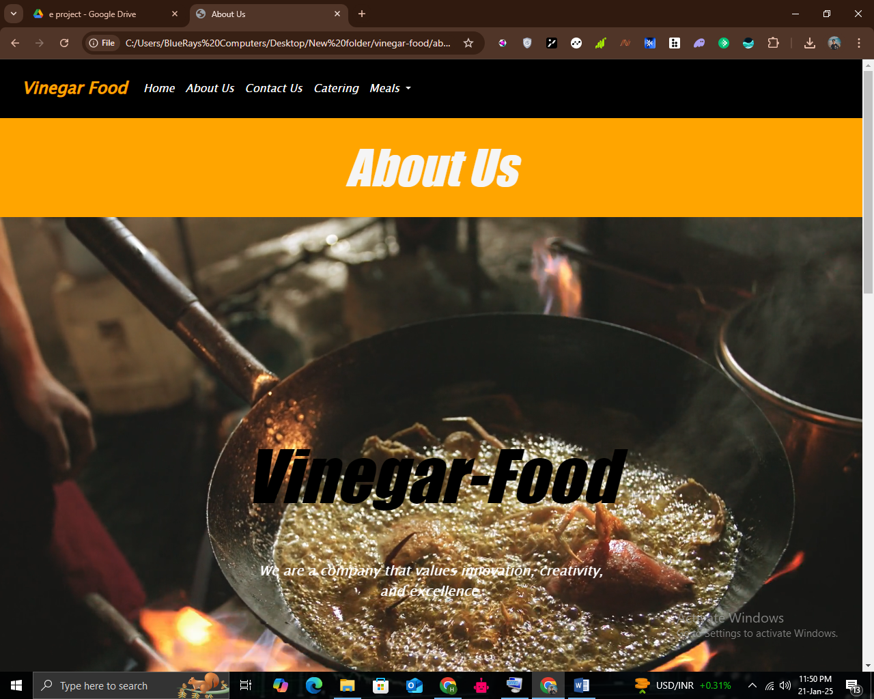

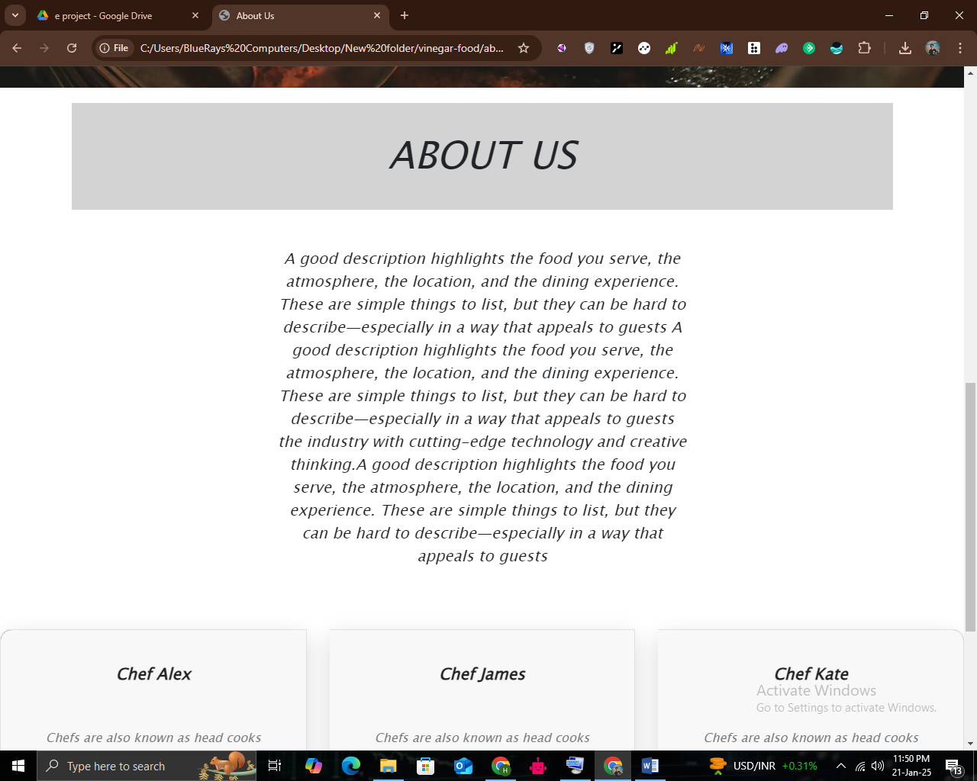

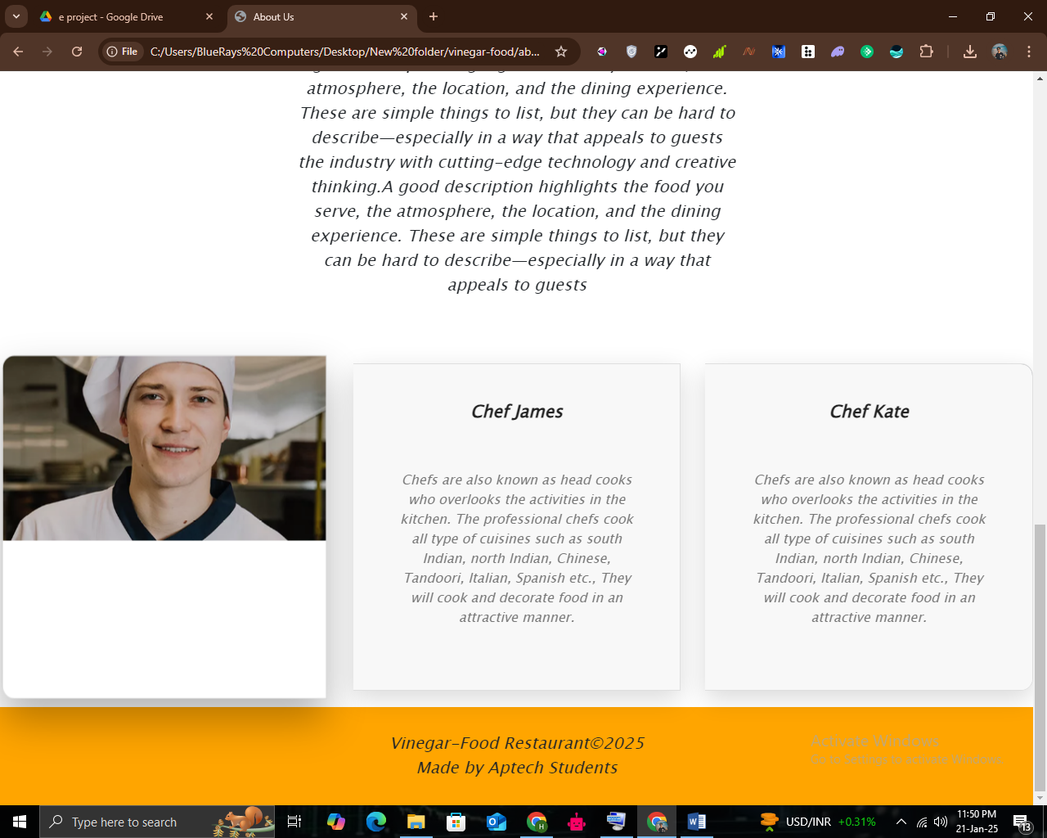

CONTACT US (contact.html)

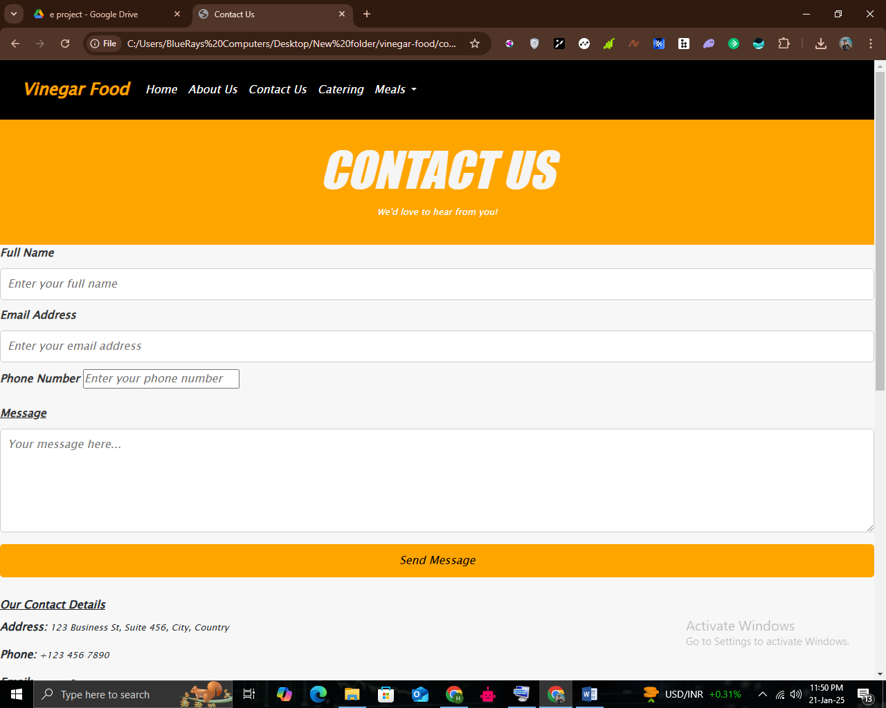

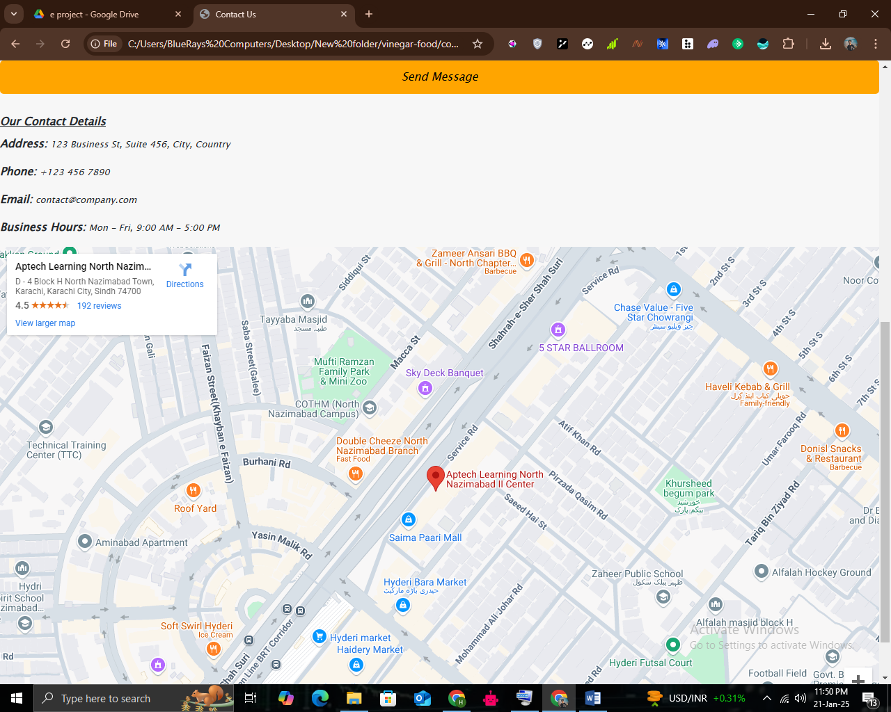

CATERING: (catering.html)

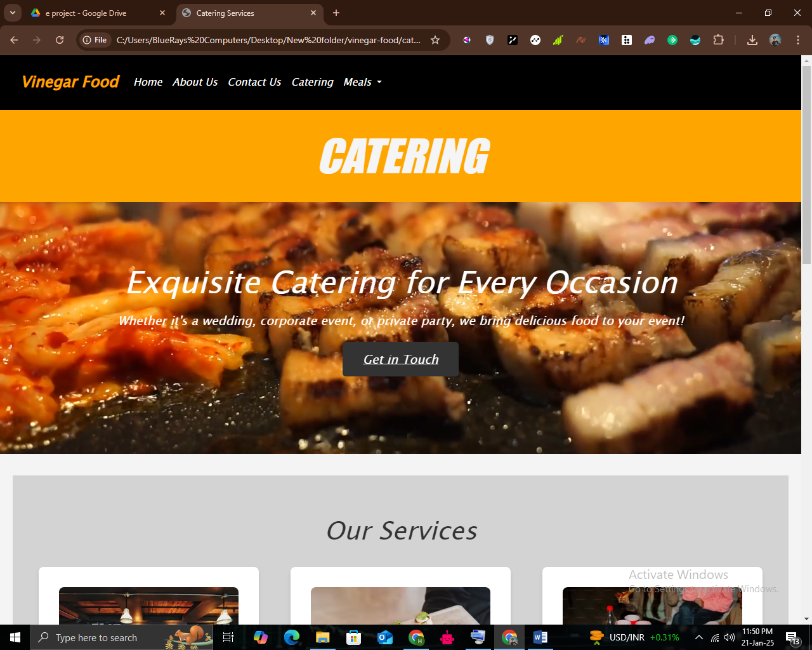

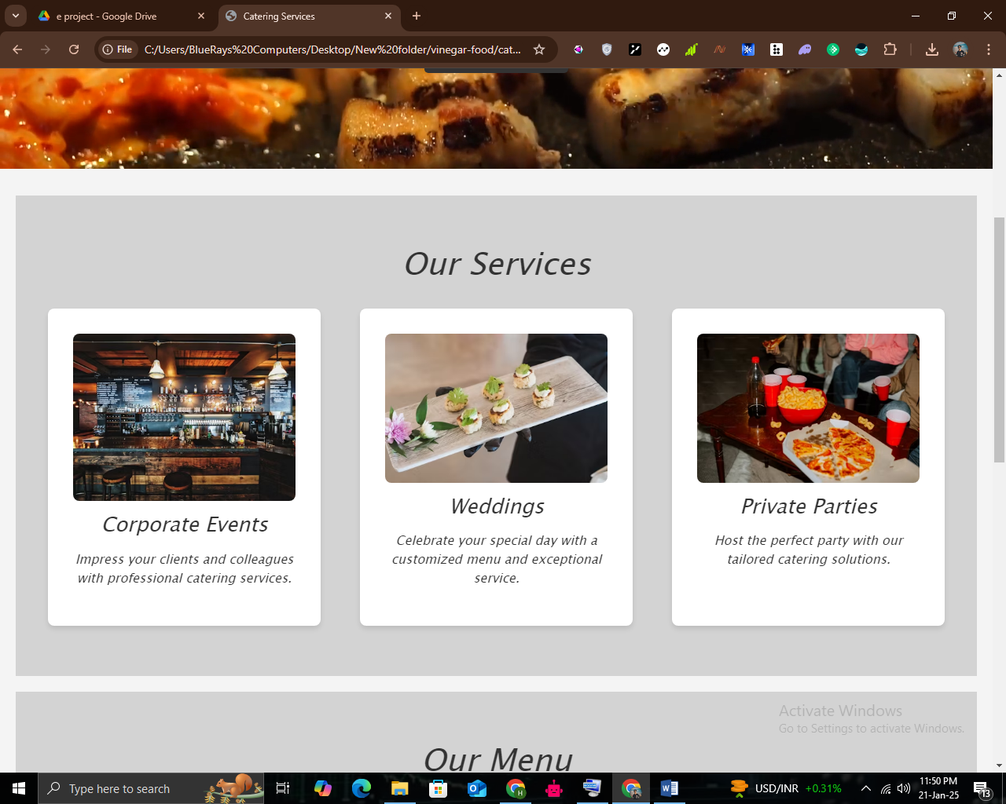

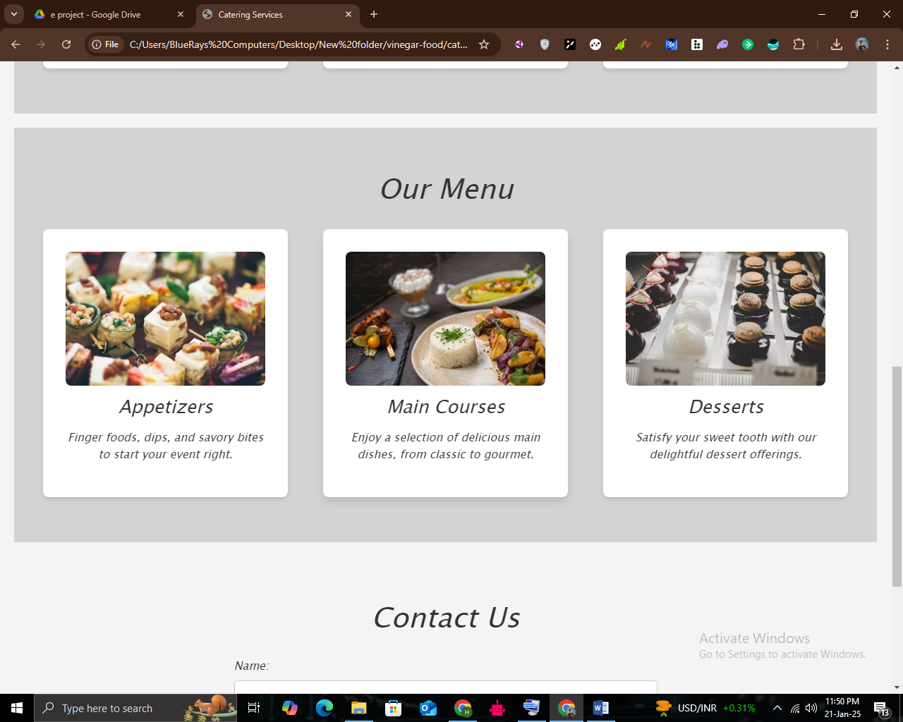

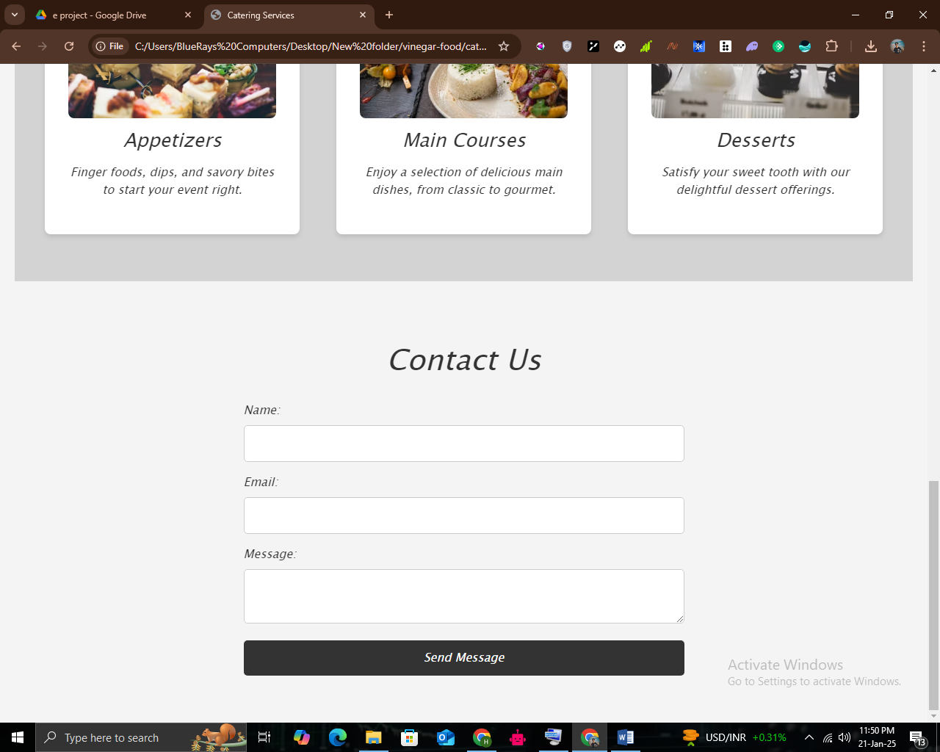

LUNCH: (lunch.html)

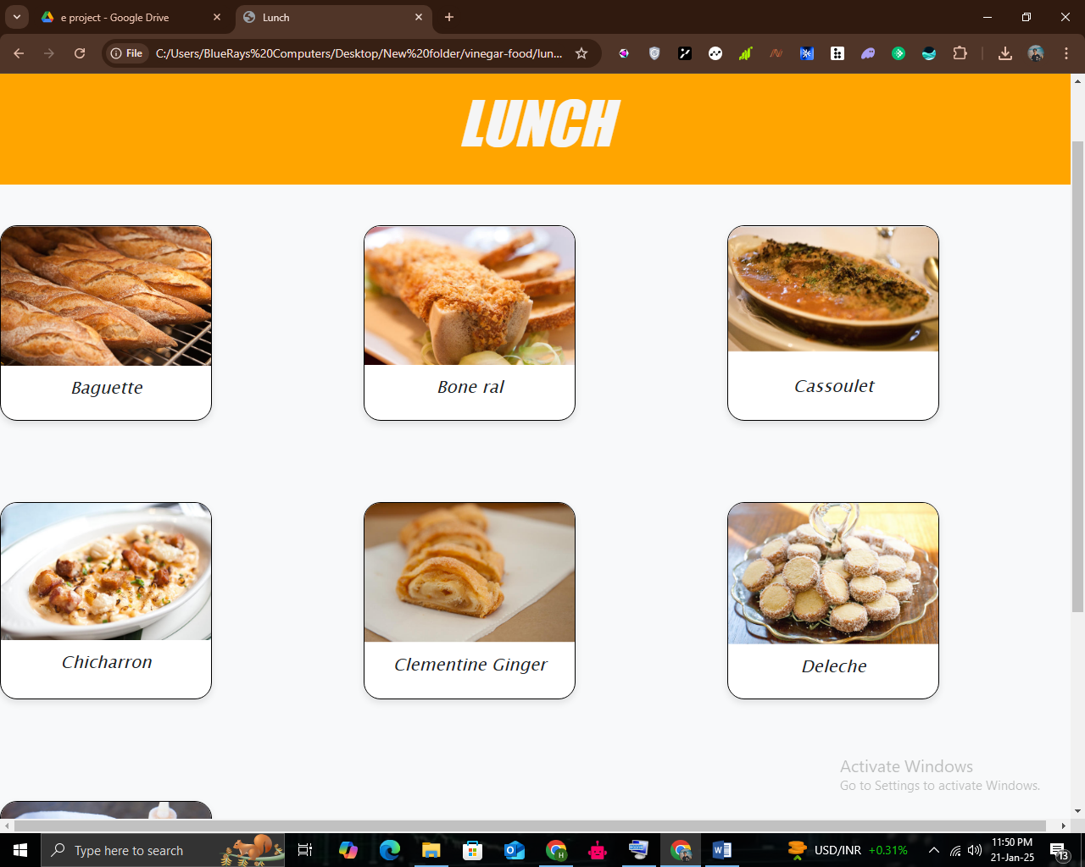

DESSERT: (dessert.html)

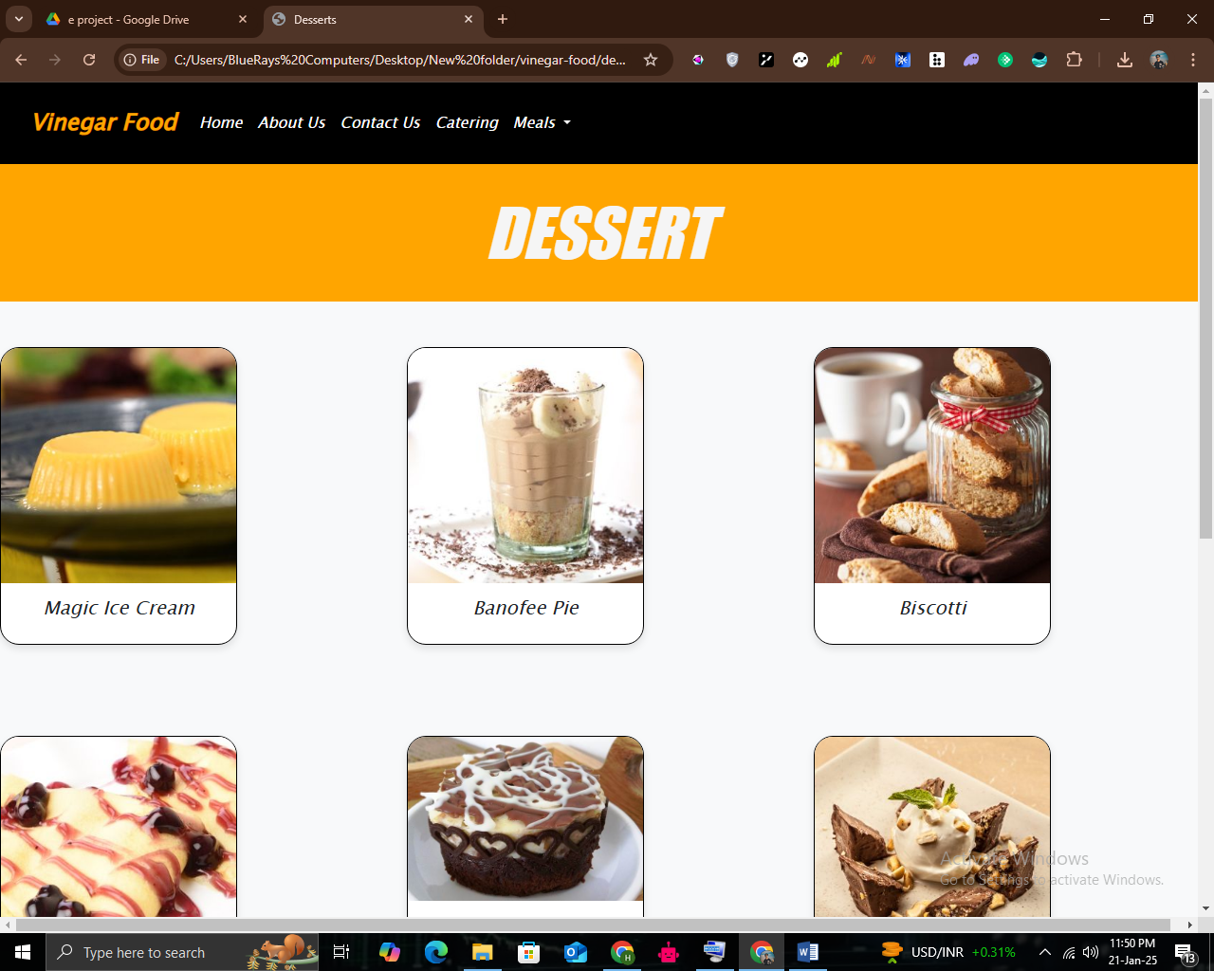

SNACK: (snack.html)

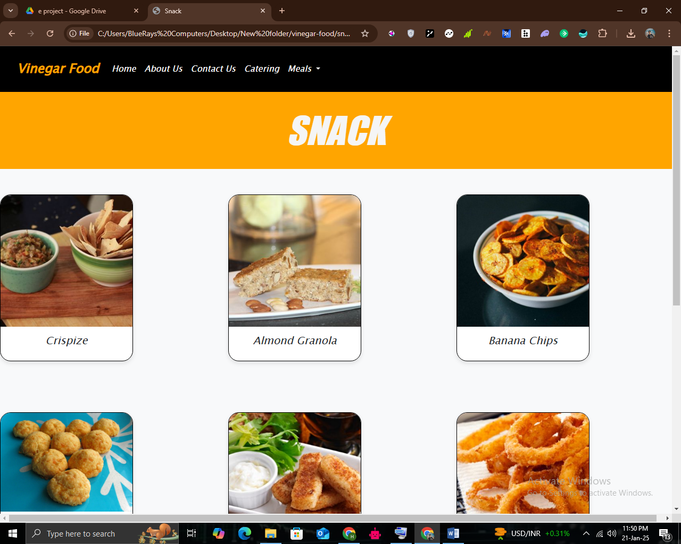

REGULAR: (regular.html)

